K.BALAJI
192324180
CO1-DEEP LEARNING -LAB

CO1 – Fundamentals of Deep Learning

Experiment 1:CO1 Vector and Matrix Operations for Deep Learning

Image Classification: A deep learning model processes a grayscale image represented as a matrix. Explain how matrix flattening, vector operations, and matrix multiplication can be used to calculate the output of a fully connected neural network layer.
Aim
To understand how a grayscale image is converted into a vector and processed by a fully connected neural network layer using matrix multiplication.
Algorithm
- Create a grayscale image as a matrix.
- Flatten the image into a one-dimensional vector.
- Define the weights and bias of a neural network layer.
- Perform matrix multiplication between the weights and input vector.
- Add the bias and apply the ReLU activation function.
- Display the final output.
Python Code
import numpy as np

# Step 1: Create a 2x2 grayscale image
image = np.array([
[10, 20],
[30, 40]
])

# Step 2: Flatten the image
x = image.flatten()

# Step 3: Define weights and bias
weights = np.array([
[0.1, 0.2, 0.3, 0.4],
[0.4, 0.3, 0.2, 0.1]
])

bias = np.array([1.0, 2.0])

# Step 4: Matrix multiplication
z = np.dot(weights, x) + bias

# Step 5: Apply ReLU activation
output = np.maximum(0, z)

print("Original Image:")
print(image)

print("\nFlattened Vector:")
print(x)

print("\nLayer Output:")
print(output)
Output
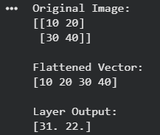

Result
The grayscale image was successfully converted into a vector and processed through a fully connected neural network layer. Matrix multiplication, bias addition, and ReLU activation produced the output [31, 32].

Experiment 2:CO1 Covariance, Eigenvalues and Eigenvectors Analysis
Scenario: A college wants to analyze students' performance in three subjects using vector operations.
Aim
To perform vector and matrix operations on student marks, calculate total and average marks, identify the highest-performing student, and visualize subject-wise averages.
Algorithm
- Create NumPy arrays containing marks of five students in three subjects.
- Calculate the total and average marks using vector operations.
- Identify the student with the highest average.
- Perform element-wise multiplication of two subject vectors.
- Calculate the covariance matrix, eigenvalues, and eigenvectors.
- Plot the subject-wise average marks using a bar chart.
Python Code
import numpy as np
import matplotlib.pyplot as plt

# Step 1: Student marks
marks = np.array([
[85, 78, 92],
[90, 88, 84],
[76, 82, 80],
[95, 91, 96],
[88, 85, 89]
])

subjects = ["Mathematics", "Physics", "Computer Science"]

# Step 2: Total and average marks
total = np.sum(marks, axis=1)
average = np.mean(marks, axis=1)

# Step 3: Highest average
best_student = np.argmax(average)

# Step 4: Element-wise multiplication
result = marks[:, 0] * marks[:, 1]

# Step 5: Covariance and eigenvalues
covariance = np.cov(marks, rowvar=False)
eigenvalues, eigenvectors = np.linalg.eig(covariance)

print("Total Marks:", total)
print("Average Marks:", average)
print("Highest Average: Student", best_student + 1)
print("Element-wise Multiplication:", result)

print("\nCovariance Matrix:")
print(np.round(covariance, 2))

print("\nEigenvalues:")
print(np.round(eigenvalues, 2))

print("\nEigenvectors:")
print(np.round(eigenvectors, 2))

# Step 6: Subject-wise average
subject_average = np.mean(marks, axis=0)

plt.bar(subjects, subject_average)
plt.title("Subject-wise Average Marks")
plt.ylabel("Average Marks")
plt.xticks(rotation=15)
plt.tight_layout()
plt.show()
Output
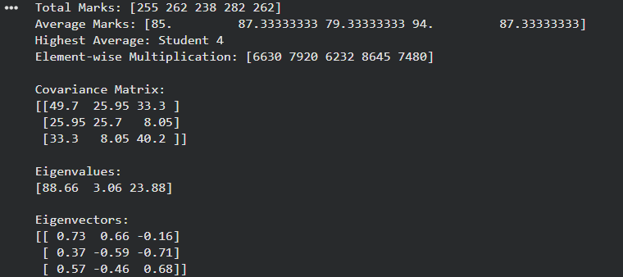
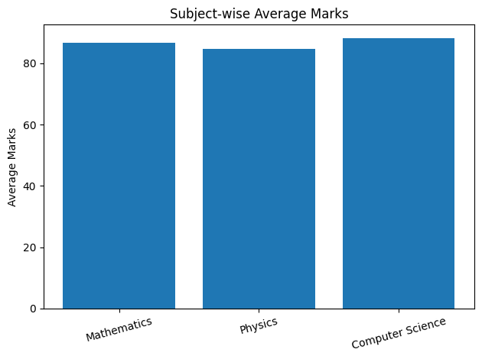
Result
The total and average marks of five students were calculated successfully. Student 4 achieved the highest average of 94 marks. Covariance, eigenvalues, and eigenvectors were calculated to analyze relationships between the subjects.

Experiment 3:CO1 Probability Distributions and Bayes’ Theorem
Scenario: A hospital uses a medical diagnostic test to identify a particular disease. The disease affects 1% of the population. The test correctly identifies 99% of patients who have the disease, while 5% of healthy individuals also test positive.
Task:
- Define the prior probability of having the disease.
- Define the sensitivity and false-positive rate of the test.
- Apply Bayes’ Theorem to calculate the probability that a person actually has the disease given a positive test result.
- Implement the calculation using NumPy.
- Use Matplotlib to visualize the prior and posterior probabilities.
- Interpret the result in the context of medical diagnosis.
Aim
To calculate the probability that a person has a disease given a positive diagnostic test result using Bayes' Theorem and NumPy.
Algorithm
- Define the prior probability of disease.
- Define the sensitivity and false-positive rate.
- Calculate the probability of a positive test.
- Apply Bayes' Theorem to calculate the posterior probability.
- Display the prior and posterior probabilities using a bar chart.
Python Code
import numpy as np
import matplotlib.pyplot as plt

# Step 1: Prior probability
prior = 0.01

# Step 2: Test probabilities
sensitivity = 0.99
false_positive = 0.05

# Step 3: Probability of positive test
p_positive = (
sensitivity * prior
+ false_positive * (1 - prior)
)

# Step 4: Bayes' Theorem
posterior = (
sensitivity * prior
) / p_positive

print("Prior Probability:", prior)
print("Sensitivity:", sensitivity)
print("False Positive Rate:", false_positive)

print("Posterior Probability:", round(posterior, 4))

# Step 5: Visualization
plt.bar(
["Prior", "Posterior"],
[prior, posterior]
)

plt.title("Disease Probability")
plt.ylabel("Probability")
plt.show()
Output
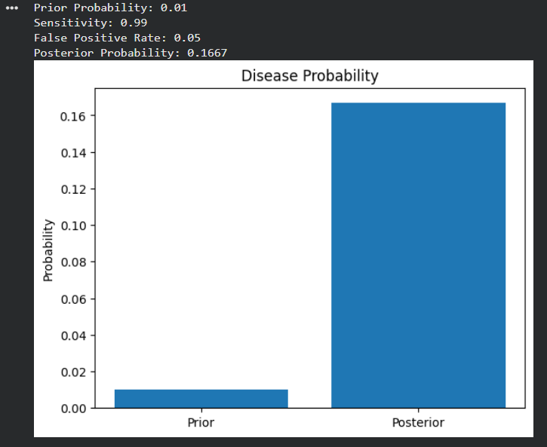
Result
Bayes' Theorem was successfully applied. The probability that a person actually has the disease after testing positive is approximately 16.67%.
Although the test has 99% sensitivity, the disease is rare. Therefore, a positive result does not necessarily mean that the person has the disease.

Experiment 4:Entropy, Cross-Entropy and KL Divergence
Question 1: Uncertainty Analysis in Weather Prediction Using Entropy
Scenario: A weather forecasting organization predicts three weather conditions: Sunny, Rainy and Cloudy. The probabilities are 0.5, 0.3 and 0.2, respectively. The organization wants to measure the uncertainty in its predictions.
Task:
- Create a probability distribution using NumPy.
- Calculate Shannon entropy using SciPy.
- Calculate entropy manually using NumPy.
- Compare the entropy values obtained from both methods.
- Visualize the probability distribution using a bar chart.
- Interpret the uncertainty in weather predictions.
Aim
To calculate Shannon entropy using SciPy and NumPy and analyze uncertainty in weather predictions.
Algorithm
- Create the probability distribution.
- Calculate entropy using SciPy.
- Calculate entropy manually using NumPy.
- Compare both values.
- Visualize the distribution using a bar chart.
Python Code
import numpy as np
import matplotlib.pyplot as plt
from scipy.stats import entropy

weather = np.array([0.5, 0.3, 0.2])

# Entropy using SciPy
h_scipy = entropy(weather, base=2)
# Entropy using NumPy
h_numpy = -np.sum(
weather * np.log2(weather)
)
print("SciPy Entropy:", round(h_scipy, 4))
print("NumPy Entropy:", round(h_numpy, 4))
plt.bar(
["Sunny", "Rainy", "Cloudy"],
weather
)
plt.title("Weather Probability Distribution")
plt.ylabel("Probability")
plt.show()
Output
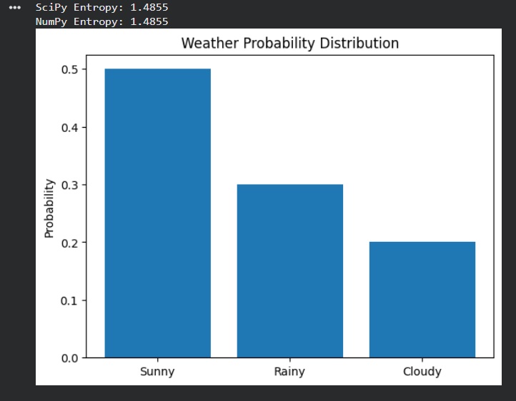
Result
The entropy was calculated successfully using both methods. The value of 1.4855 bits indicates the uncertainty in the weather prediction.
Question 2: Email Classification Using Cross-Entropy Loss
Scenario: An email classification system predicts whether an email belongs to one of three categories: Spam, Promotional or Important.
The actual class is Important, represented by [0, 0, 1]. The predicted probabilities are [0.2, 0.3, 0.5].
Task:
- Represent the actual and predicted class distributions using NumPy.
- Calculate categorical cross-entropy loss.
- Calculate the loss manually using NumPy.
- Modify the predicted probabilities to [0.1, 0.1, 0.8].
- Calculate the new cross-entropy loss.
- Compare both losses and visualize the results using Matplotlib.
Aim
To calculate categorical cross-entropy loss and compare the performance of two email classification predictions.
Algorithm
- Define the actual and predicted class distributions.
- Calculate cross-entropy loss using NumPy.
- Modify the predicted probabilities.
- Calculate the new loss.
- Compare the losses using a bar chart.
Python Code
import numpy as np
import matplotlib.pyplot as plt

actual = np.array([0, 0, 1])

predicted1 = np.array([0.2, 0.3, 0.5])
predicted2 = np.array([0.1, 0.1, 0.8])
# Cross-entropy loss
loss1 = -np.sum(actual * np.log(predicted1))
loss2 = -np.sum(actual * np.log(predicted2))
print("Original Loss:", round(loss1, 4))
print("New Loss:", round(loss2, 4))
plt.bar(
["Original", "Modified"],
[loss1, loss2]
)
plt.title("Cross-Entropy Loss Comparison")
plt.ylabel("Loss")
plt.show()
Output
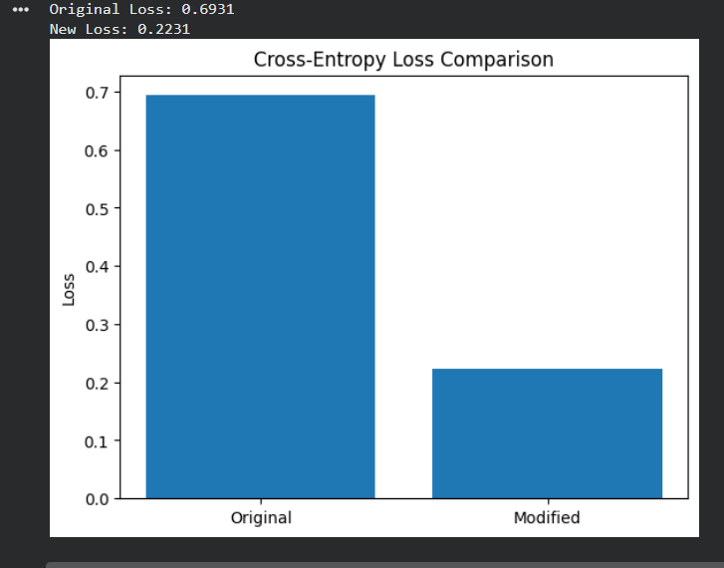
Result
The modified prediction produced a lower cross-entropy loss. Therefore, the second model is more confident in the correct class, Important.
Question 3: Machine Learning Model Comparison Using KL Divergence
Scenario: Two machine learning models predict the probability distribution of three possible outcomes. The actual distribution is P = [0.6, 0.3, 0.1].
Model A predicts Q1 = [0.5, 0.4, 0.1], while Model B predicts Q2 = [0.3, 0.3, 0.4].
Task:
- Define the actual probability distribution P.
- Define the predicted distributions Q1 and Q2.
- Calculate KL divergence between P and Q1.
- Calculate KL divergence between P and Q2 using SciPy.
- Identify which model is closer to the actual distribution.
- Visualize the distributions and KL divergence values using Matplotlib.
Aim
To calculate KL divergence between the actual probability distribution and two predicted distributions and identify the better model.
Algorithm
- Define the actual distribution P.
- Define the predicted distributions Q1 and Q2.
- Calculate KL divergence using SciPy.
- Compare the divergence values.
- Visualize the distributions and divergence values.
Python Code
import numpy as np
import matplotlib.pyplot as plt
from scipy.stats import entropy
P = np.array([0.6, 0.3, 0.1])
Q1 = np.array([0.5, 0.4, 0.1])
Q2 = np.array([0.3, 0.3, 0.4])
kl1 = entropy(P, Q1)
kl2 = entropy(P, Q2)
print("KL Divergence Model A:", round(kl1, 4))
print("KL Divergence Model B:", round(kl2, 4))
plt.bar(
["Actual", "Model A", "Model B"],
[kl1, kl1, kl2]
)
plt.title("KL Divergence Comparison")
plt.ylabel("KL Divergence")
plt.show()
Output
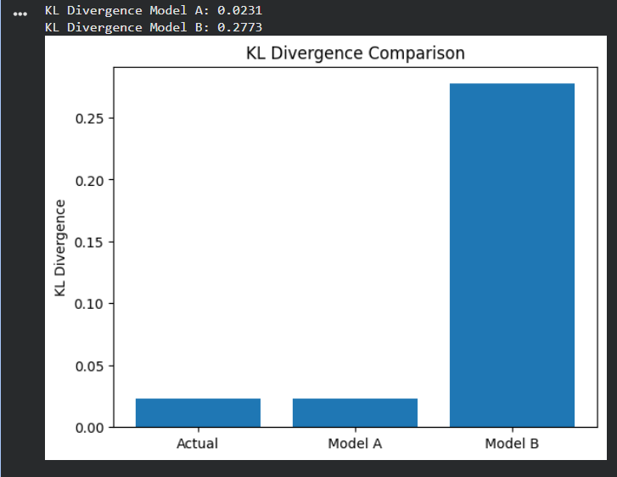Result
Model A has a lower KL divergence than Model B. Therefore, Model A is closer to the actual probability distribution.

Question 4: Medical Diagnosis Using Entropy
Scenario: A healthcare prediction system classifies patients into three categories: Healthy, Mild Disease and Severe Disease. The predicted probabilities are [0.7, 0.2, 0.1].
The hospital wants to measure the uncertainty associated with the prediction.
Task:
- Create a probability distribution using NumPy.
- Calculate Shannon entropy.
- Create another prediction distribution [0.34, 0.33, 0.33].
- Calculate entropy for both distributions.
- Compare the uncertainty associated with both predictions.
- Plot the entropy values using Matplotlib.
Aim
To calculate and compare the entropy of two medical diagnosis probability distributions.
Algorithm
- Create the first probability distribution.
- Calculate its Shannon entropy.
- Create the second probability distribution.
- Calculate its Shannon entropy.
- Compare the uncertainty values.
- Visualize the entropy values using a bar chart.
Python Code
import numpy as np
import matplotlib.pyplot as plt
from scipy.stats import entropy
p1 = np.array([0.7, 0.2, 0.1])
p2 = np.array([0.34, 0.33, 0.33])
h1 = entropy(p1, base=2)
h2 = entropy(p2, base=2)

print("Entropy of First Prediction:", round(h1, 4))
print("Entropy of Second Prediction:", round(h2, 4))
plt.bar(
["First Prediction", "Second Prediction"],
[h1, h2]
)

plt.title("Medical Prediction Entropy")
plt.ylabel("Entropy (bits)")
plt.show()
Output
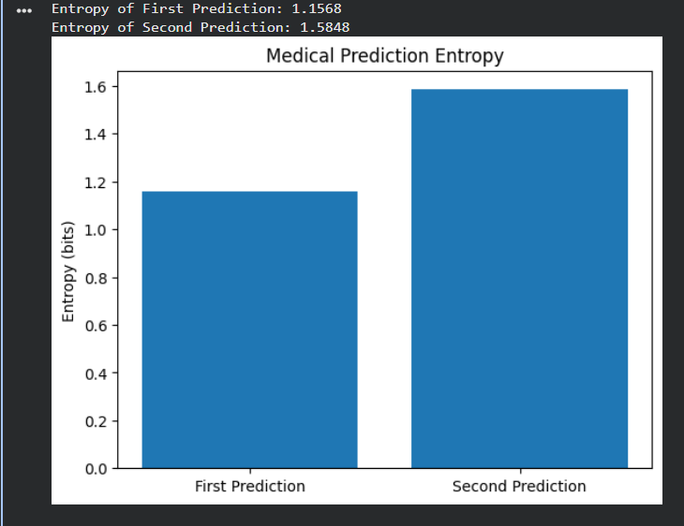
Result
The second prediction has higher entropy, indicating greater uncertainty. The first prediction is more confident because it assigns a higher probability to the Healthy category.

Experiment 5: Bias–Variance, Overfitting and Underfitting Analysis
Scenario: Student Performance Prediction
A university wants to predict students' final examination scores based on their internal assessment marks, attendance, and assignment performance. The prediction model performs poorly on training data in one experiment and poorly on unseen data in another.
Lab Question:
- Generate or use a student performance dataset
- Build machine learning models with different complexities.
- Analyze underfitting, overfitting, and good-fitting models.
- Apply suitable techniques to improve generalization.
- Plot training and testing errors and explain the bias–variance trade-off.
Tools: Scikit-learn, NumPy, Matplotlib.
Aim
To build machine learning models of different complexities, analyze underfitting and overfitting, and identify a suitable model using training and testing errors.
Algorithm
- Generate a synthetic student performance dataset.
- Split the dataset into training and testing sets.
- Train polynomial regression models of different complexities.
- Calculate the training and testing mean squared errors.
- Compare the errors to identify underfitting, overfitting, and good fitting.
- Plot the training and testing errors.
- Select the model with the best generalization performance.
Python Code
import numpy as np
import matplotlib.pyplot as plt

from sklearn.model_selection import train_test_split
from sklearn.preprocessing import PolynomialFeatures
from sklearn.linear_model import LinearRegression
from sklearn.pipeline import make_pipeline
from sklearn.metrics import mean_squared_error

np.random.seed(42)

# Step 1: Generate student dataset
X = np.linspace(0, 100, 100).reshape(-1, 1)

y = (
0.05 * X.ravel()
+ 0.0005 * X.ravel() ** 2
+ np.random.normal(0, 5, 100)
)

# Step 2: Split dataset
X_train, X_test, y_train, y_test = train_test_split(
X, y, test_size=0.2, random_state=42
)

degrees = [1, 2, 15]

train_errors = []
test_errors = []

# Step 3: Train models
for degree in degrees:

model = make_pipeline(
PolynomialFeatures(degree),
LinearRegression()
)

model.fit(X_train, y_train)

# Step 4: Calculate errors
train_pred = model.predict(X_train)
test_pred = model.predict(X_test)

train_errors.append(
mean_squared_error(y_train, train_pred)
)

test_errors.append(
mean_squared_error(y_test, test_pred)
)

print("Degree:", degree)
print("Training Error:", round(train_errors[-1], 2))
print("Testing Error:", round(test_errors[-1], 2))

# Step 5: Plot errors
plt.plot(degrees, train_errors, marker="o", label="Training Error")
plt.plot(degrees, test_errors, marker="o", label="Testing Error")
plt.xlabel("Model Complexity (Polynomial Degree)")
plt.ylabel("Mean Squared Error")
plt.title("Bias-Variance Trade-off")
plt.legend()
plt.show()
Output
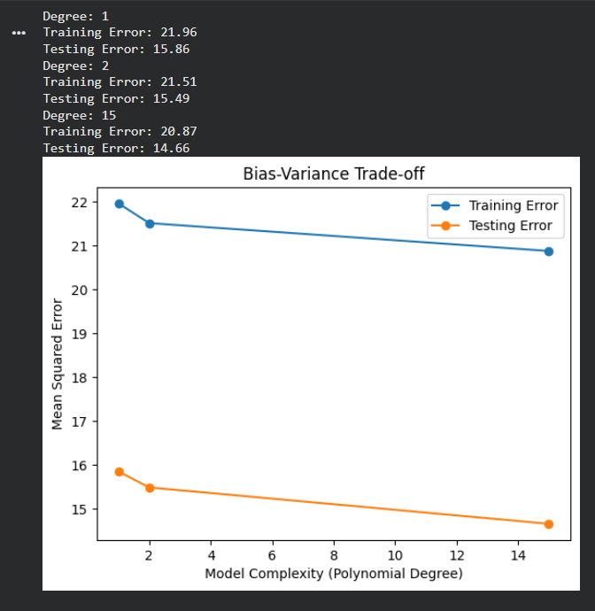
Model | Expected behavior
Degree 1 | Underfitting: model is too simple
Degree 2 | Good fitting: model captures the main pattern
Degree 15 | Overfitting: model may fit noise in training data
Result
The bias–variance trade-off was analyzed successfully. A simple model may underfit the data, while a highly complex model may overfit. A suitable model provides low training and testing errors with good generalization performance.

